

**Ravensworth Terrace Primary School**



**Online Safety Policy**

Updated February 2022



**POLICY DOCUMENTATION**

# Scope of the Policy

This policy applies to all members of Ravensworth Terrace Primary (including staff, pupils, volunteers, parents / carers, visitors, student teachers, community users) who have access to and are users of school computing systems, both in and out of the *school.*

The Education and Inspections Act 2006 empowers Headteachers to such extent as is reasonable, to regulate the behaviour of pupils when they are off the school site and empowers members of staff to impose disciplinary penalties for inappropriate behaviour. This is pertinent to incidents of cyber-bullying, or other online safety incidents covered by this policy, which may take place outside of the school, but is linked to membership of the school. The 2011 Education Act increased these powers with regard to the searching for and of electronic devices and the deletion of data. In the case of both acts, action can only be taken over issues covered by the published Behaviour Policy.

Ravensworth Terrace Primary School will deal with such incidents within this policy and associated behaviour and anti-bullying policies and will, where known, inform parents / carers of incidents of inappropriate behaviour online, that take place out of school.

# Roles and Responsibilities

The following section outlines the online safety roles and responsibilities of individuals and groups at Ravensworth Terrace.

* Head Teacher – child protection, use of Impero to monitor appropriate internet usage, discussions with parents in line with behaviour policy.
* Deputy Head– child protection, use of Impero to monitor appropriate internet usage, discussions with parents in line with the school’s behaviour policy.
* Computing Lead– organise external online safety sessions where appropriate, support with teaching of Online safety and safe behaviours when using technology. •
* Teachers and support staff – delivery of Online Safety sessions, monitor children’s use of IT

**Governors:**

*Governors* are responsible for the approval of the Online Safety Policy and for reviewing the effectiveness of the policy. This will be carried out by the *Governors* receiving regular information about e -safety incidents and monitoring reports. A member of the *Governing Body, David Horn* has taken on the role of *computing and ICT Governor which encompasses Online safety*.

**The role of the Online Safety *Governor.***

* *regular monitoring of forensic software and reports,*
* *regular monitoring of filtering,*
* *reporting to relevant Governors,*

**Head Teacher and Senior Leaders:**

* The Head Teacher has a duty of care for ensuring the safety (including online safety) of members of the school community, though the day to day responsibility for online safety will be delegated to the computing lead and teaching staff.
* The Head Teacher, Deputy Head Teacher and Business Manager should be aware of the procedures to be followed in the event of a serious e-safety allegation being made against a member of staff.
* The Head teacher and Senior Leaders are responsible for ensuring that the Computing Lead and other relevant staff receive suitable training to enable them to carry out their online safety roles and to train other colleagues.
* The Head teacher and Senior Leaders will ensure that there is a system in place to allow for

monitoring and support of those in school who carry out the internal e-safety monitoring role.

This is to provide a safety net and also support to those colleagues who take on important

monitoring roles.

* The Senior Leadership Team will receive regular monitoring reports from forensic software reports on internet usage and websites visited.

**Network Manager (Local Authority):**

The Local Authority is responsible for ensuring:

* that the school’s technical infrastructure is secure and is not open to misuse or malicious attack.
* that the school meets required online safety technical requirements.
* that users may only access the networks and devices through a properly enforced password protection policy, in which passwords are regularly changed.
* *the filtering policy and procedures is applied and updated on a regular basis and that its implementation is not the sole responsibility of any single person*.
* that they keep up to date with e-safety technical information in order to effectively carry out their e-safety role and to inform and update others as relevant.
* that the use of the network/internet/Virtual Learning Environment/remote access/email is regularly monitored in order that any misuse/attempted misuse can be reported to the Head Teacher for investigation.
* that monitoring software/systems are implemented and updated as agreed in school policies.

## Acceptable usage policy (AUP)

* This device and all devices in our school are monitored in the interests of e-safety. Suspected breaches of this AUP will be recorded by forensic software and referred for review.

**The policy**

In the interests of keeping our students and staff safe whilst using technology we have made the decision to deploy e-safety monitoring software. This software works by measuring the digital behaviour of users against the agreed acceptable use policy. Suspected breaches of the policy are immediately reported with serious breaches being captured by Impero Software. The personnel responsible for receiving and reviewing reports are Ms D Thompson (Head Teacher) and Mrs Claire Brooks (Deputy Head). Behaviour, safeguarding and other incidents arising from the review of this data will be handled in line with our school policy and procedures.

**Teaching and Support Staff**

are responsible for ensuring that:

* they have an up to date awareness of online safety matters and of the current *school* e-safety policy and practices.
* they have read, understood and agreed the Staff Acceptable Use Policy/Agreement (AUP)
* they report any suspected misuse or problem to the *Head teacher* for investigation, action or sanction.
* all digital communications with pupils/parents/carers should be on a professional level *and only carried out using official school systems.*
* Online safety issues are embedded in all aspects of the curriculum and other activities.
* Pupils understand and follow the online safety and acceptable use policies (child friendly adapted version created by staff and digital leaders)
* Pupils have a good understanding of research skills and the need to avoid plagiarism and uphold copyright regulations.
* they monitor the use of digital technologies, mobile devices, cameras etc in lessons and other school activities (where allowed) and implement current policies with regard to these devices.
* They monitor how they use Youtube in classrooms (this can only be accessed by logging in on teacher accounts and manually allowing the security certificates to run).
* in lessons where internet use is pre-planned pupils should be guided to sites checked as suitable for their use and that processes are in place for dealing with any unsuitable material that is found in internet searches.

**Child Protection Officer/Designated Person(s)**

should be trained in e-safety issues and be aware of the potential for serious child protection/ safeguarding issues to arise from:

* sharing of personal data.
* access to illegal / inappropriate materials.
* inappropriate on-line contact with adults / strangers.
* potential or actual incidents of grooming.
* cyber-bullying.

**Pupils:**

* are responsible for using the *schools* digital technology systems in accordance with the Pupil Acceptable Use Policy, (children discuss and agree to follow the acceptable use policy at the beginning of each year group and it is revisited before accessing the internet). Posters (SMART with a Heart posters which were created by the school’s digital leaders) are displayed in all classrooms act as a prompt.
* have a good understanding of research skills and the need to avoid plagiarism and uphold copyright regulations.
* need to understand the importance of reporting abuse, misuse or access to inappropriate materials and know how to do so.
* will be expected to know and understand policies on the use of mobile devices and digital cameras. They should also know and understand policies on the taking / use of images and on cyber-bullying.
* should understand the importance of adopting good online safety practice when using digital technologies out of school and realise that the *school’s* E-Safety Policy covers their actions out of school, if related to their membership of the school.

**Parents/Carers:**

Parents/Carers play a crucial role in ensuring that their children understand the need to use the internet/mobile devices in an appropriate way. Upon entry to school, the parents sign the Acceptable Use Policy. We will take every opportunity to help parents understand issues relating to online safety through parents’ evenings, newsletters, letters, website and information about national and local online safety campaigns and literature. Parents and carers will be encouraged to support the school in promoting good online safety practice and to follow guidelines on the appropriate use of:

* digital and video images taken at school events.
* access to parents’ sections of the website.
* their children’s personal devices in the school (Mobile phones for children who walk home in UKS2)

**Community Users:**

Community Users who access school systems/website as part of the wider school provision will be expected to sign a Community User Automated User Agreement before being provided with access to school systems. This is a digital signature before a user log in to a school computer.

**Policy Statements**

## Education – pupils

Whilst regulation and technical solutions are very important, their use must be balanced by educating *pupils* to take a responsible approach. The education of *pupils* in e-safety is therefore an essential part of the school’s e-safety provision. Children and young people need the help and support of the school to recognise and avoid e-safety risks and build their resilience.

**Online safety should be a focus in all areas of the curriculum and staff should reinforce online safety messages across the curriculum. At Ravensworth Terrace, all eSafety teaching is in line with ‘Education for a Connected World 2021’. The online safety curriculum should be broad, relevant and provide progression, with opportunities for creative activities and will be provided in the following ways:**

* A planned online safety curriculum should be provided as part of Computing/PSHE/other lessons and should be regularly revisited.
* ESafety lessons will take place every half-term as part of the computing curriculum and are non-negotiable.
* The curriculum is divided into 8 strands and each strand must be covered in each year group, throughout the year.
* Key online safety messages should be reinforced as part of a planned programme of assemblies and pastoral activities. (Using the SMART with a heart poster)
* Pupils should be taught in all lessons to be critically aware of the materials and content they access on-line and be guided to validate the accuracy of information.
* Pupils should be taught to acknowledge the source of information used and to respect copyright when using material accessed on the internet.
* Pupils should be helped to understand the need for the Acceptable Use Agreement and encouraged to adopt safe and responsible use both within and outside school.
* Staff should act as good role models in their use of digital technologies, the internet and mobile devices.
* In lessons where internet use is pre-planned, it is best practice that pupils should be guided to sites checked as suitable for their use and that processes are in place for dealing with any unsuitable material that is found in internet searches.
* Where pupils are allowed to freely search the internet, staff should be vigilant in monitoring the content of the websites the pupils visit. Forensic software will also enable robust monitoring of internet usage and sites visited.
* It is accepted that from time to time, for good educational reasons, pupils may need to research topics (e.g. racism, drugs, discrimination) that would normally result in internet searches being blocked. In such a situation, staff can request that the local authority can temporarily remove those sites from the filtered list for the period of study. Any request to do so, should be auditable, with clear reasons for the need.

## Education – Parents/Carers

Many parents and carers have only a limited understanding of e-safety risks and issues, yet they play an essential role in the education of their children and in the monitoring and regulation of the children’s on-line behaviours. Parents may underestimate how often children and young people come across potentially harmful and inappropriate material on the internet and may be unsure about how to respond.

We will therefore seek to provide information and awareness to parents and carers through:

* *Curriculum activities.*
* *Letters, newsletters, web site, social media.*
* *Technology Tuesdays – sharing eSafety guides and advice on Class Dojo School Story.*
* *Parents/Carers consultations.*
* *High profile events and campaigns (e.g. Safer Internet Day).*
* *Reference to the relevant web sites/publications.*

## Education – The Wider Community

* We will provide opportunities for local community groups and members of the community to gain from the school’s e-safety knowledge and experience. This may be offered through the following:
* Providing family learning courses in use of new digital technologies, digital literacy and e-safety.
* Online Safety messages targeted towards grandparents and other relatives as well as parents.
* The school website will provide online safety information for the wider community.
* Supporting community groups (eg Early Years Settings, Childminders, youth/sports/voluntary groups) to enhance their online safety provision.

## Education & Training – Staff/Volunteers

It is essential that all staff receive online safety training and understand their responsibilities, as outlined in this policy. Training will be offered as follows:

* A planned programme of formal e-safety training will be made available to staff. This will be regularly updated and reinforced. An audit of the e-safety training needs of all staff will be carried out regularly.
* All new staff should receive e-safety training as part of their induction programme, ensuring that they fully understand the school e-safety policy and Acceptable Use Agreements.
* The Head Teacher will receive regular updates through attendance at external training events (e.g. from the Local Authority).
* This Online Safety policy and its updates will be presented to and discussed by staff in staff and team meetings.

The Head Teacher and computing manager will provide guidance and training to individuals as required.

## Training – Governors

**Governors should take part in e-safety training and awareness sessions**, with particular importance for those who are members of any subcommittee or group involved in technology, online safety, health and safety and/or child protection. This may be offered in a number of ways:

* Attendance at training provided by the Local Authority/National Governors Association/or other relevant organisation,
* Participation in school training/information sessions for staff or parents (this may include attendance at assemblies and lessons).

## Technical – infrastructure/equipment, filtering and monitoring

We will be responsible for ensuring that the school infrastructure and network is as safe and secure as is reasonably possible and that policies and procedures approved within this policy are implemented. It will also need to ensure that the relevant people named in the above sections will be effective in carrying out their e-safety responsibilities:

* School technical systems will be managed in ways that ensure that the school meets recommended technical requirements outlined by Gateshead Local Authority.
* There will be regular reviews and audits of the safety and security of school technical systems.
* Servers, wireless systems and cabling must be securely located and physical access restricted.
* All users will have clearly defined access rights to school technical systems and devices.
* All users will be provided with a username and secure password the local authority *who will keep an up to date record of users and their usernames.* Users are responsible for the security of their username and password *and will be required to change their password every term.*
* The “master/administrator” passwords for the school ICT system, used by the Local Authority must also be available to the *Head Teacher and* kept in a secure place (e.g. school safe).
* The computing manager is responsible for ensuring that software licence logs are accurate and up to date and that regular checks are made to reconcile the number of licences purchased against the number of software installations.
* Internet access is filtered for all users. Illegal content (child sexual abuse images) is filtered by the broadband or filtering provider by actively employing the forensic software. Content lists are regularly updated and internet use is logged and regularly monitored. There is a clear process in place to deal with requests for filtering changes.
* *The school has provided enhanced and differentiated user-level filtering* (staff accounts can access YouTube).
* **Forensic software, Impero,** is used to track internet traffic. It uses code and algorithms to spot unsafe, harmful or inappropriate search terms, words and images. Its findings are sent live to Ms Denise Thompson and Mrs Claire Brooks, screen captures will also be taken.
* *School staff regularly monitor and record the activity of users on the school technical systems and users are made aware of this in the Acceptable Use Agreement.*
* *An appropriate system is in place whereby users reports report any actual or potential technical incident and security breach to the computing manager.*
* Appropriate security measures are in place including the forensic software to protect the servers, firewalls, routers, wireless systems, work stations, mobile devices etc. from accidental or malicious attempts which might threaten the security of the school systems and data. These are tested regularly. The school infrastructure and individual workstations are protected by up to date virus software.
* An agreed policy is in place (SS1 accounts) for the provision of temporary access of “guests” (e.g. trainee teachers, supply teachers, visitors) onto the school systems.
* *An agreed policy is in place (no use of person technologies or social medias during directed time in school) regarding the extent of personal use that users (staff/pupils/community users) and their family members are allowed on school devices that may be used out of school.*
* *Users are unable to download executable files without Local Authority consent.*
* *An agreed policy is in place regarding the use of removable media (e.g. memory sticks/CDs/ DVDs) by users on school devices. Personal data cannot be sent over the internet or taken off the school site unless safely encrypted or otherwise secured. Each staff member has an encrypted memory stick.*

## Use of digital and video images

The development of digital imaging technologies has created significant benefits to learning, allowing staff and pupils instant use of images that they have recorded themselves or downloaded from the internet. However, staff, parents / carers and pupils need to be aware of the risks associated with publishing digital images on the internet. Such images may provide avenues for cyberbullying to take place. Digital images may remain available on the internet forever and may cause harm or embarrassment to individuals in the short or longer term. It is common for employers to carry out internet searches for information about potential and existing employees. The school will inform and educate users about these risks and will implement policies to reduce the likelihood of the potential for harm:

* When using digital images, staff should inform and educate pupils about the risks associated with the taking, use, sharing, publication and distribution of images. In particular they should recognise the risks attached to publishing their own images on the internet eg on social networking sites.
* In accordance with guidance from the Information Commissioner’s Office, parents/carers are welcome to take videos and digital images of their children at school events for their own personal use (as such use in not covered by the Data Protection Act). To respect everyone’s privacy and in some cases protection, these images should not be published/made publicly available on social networking sites, nor should parents/carers comment on any activities involving other *pupils* in the digital/video images.
* *Staff and volunteers are allowed to take digital / video images to support educational aims, but must follow school policies concerning the sharing, distribution and publication of those images. Those images should only be taken on school equipment, the personal equipment of staff should not be used for such purposes.*
* *Care should be taken when taking video images that pupils are appropriately dressed and are not participating in activities that might bring the individuals or the school into disrepute.*
* *Pupils must not take, use, share, publish or distribute images of others without their*

*permission.*

* *Photographs published on the website, or elsewhere that include pupils will be selected carefully and will comply with good practice guidance on the use of such images.*
* *Pupils’ full names will not be used anywhere on a website or blog, particularly in association with photographs.*
* *Written permission from parents or carers will be obtained before photographs of pupils are published on the school website (this is done with the documentation on admission into school).*
* *Pupil’s work can only be published with the permission of the pupil.*

## Data Protection

Personal data will be recorded, processed, transferred and made available according to the Data Protection Act 1998 which states that personal data must be:

* Fairly and lawfully processed.
* Processed for limited purposes.
* Adequate, relevant and not excessive.
* Accurate.
* Kept no longer than is necessary.
* Processed in accordance with the data subject’s rights.
* Secure.
* Only transferred to others with adequate protection.

**At Ravensworth Terrace we will ensure that:**

* We will hold the minimum personal data necessary to enable it to perform its function and it will not hold it for longer than necessary for the purposes it was collected for.
* Every effort will be made to ensure that data held is accurate, up to date and that inaccuracies are corrected without unnecessary delay.
* All personal data will be fairly obtained in accordance with the “Privacy Notice” and lawfully processed in accordance with the “Conditions for Processing”.
* It has a Data Protection Policy.
* It is registered as a Data Controller for the purposes of the Data Protection Act (DPA)
* Responsible persons are appointed / identified - Senior Information Risk Officer (SIRO) and Information Asset Owners (IAOs).
* Risk assessments are carried out.
* It has clear and understood arrangements for the security, storage and transfer of personal data.
* Data subjects have rights of access and there are clear procedures for this to be obtained.
* There are clear and understood policies and routines for the deletion and disposal of data.
* There is a policy for reporting, logging, managing and recovering from information risk incidents.
* There are clear Data Protection clauses in all contracts where personal data may be passed to third parties.
* There are clear policies about the use of cloud storage / cloud computing which ensure that such data storage meets the requirements laid down by the Information Commissioner’s Office.

**Staff must ensure that they:**

* At all times take care to ensure the safe keeping of personal data, minimising the risk of its loss or misuse.
* Use personal data only on secure password protected computers and other devices, ensuring that they are properly “logged-off” at the end of any session in which they are using personal data.
* Transfer data using encryption and secure password protected devices.

When personal data is stored on any portable computer system, memory stick or any other

removable media:

* the data must be encrypted and password protected.
* the device must be password protected.
* the device must offer approved virus and malware checking software.
* the data must be securely deleted from the device, in line with school policy (below) once it has been transferred or its use is complete.

## Communications

A wide range of rapidly developing communications technologies has the potential to enhance learning. The following table shows how the school currently considers the benefit of using these technologies for education outweighs their risks or disadvantages:

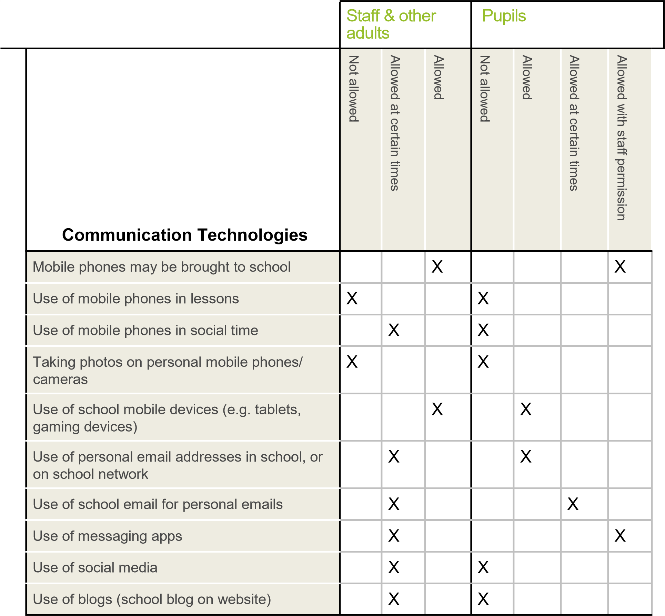

When using communication technologies the school considers the following as good practice:

* **The official *school* email service may be regarded as safe and secure and is monitored.****Users should be aware that email communications are monitored.**  *Staff and pupils should therefore use only the school email service to communicate with others when in school, or on school (by remote access).*
* **Users must immediately report, to the nominated person (Head Teacher) – in accordance with the school policy, the receipt of any communication that makes them feel uncomfortable, is offensive, discriminatory, threatening or bullying in nature and must not respond to any such communication.**
* **Any digital communication between staff and pupils or parents/carers (email, social medias, parent mail etc) must be professional in tone and content.** *These communications may only take place on official (monitored) school systems. Personal email addresses, text messaging or social media must not be used for these communications.*
* *Pupils should be taught about e-safety issues, such as the risks attached to the sharing of personal details. They should also be taught strategies to deal with inappropriate communications and be reminded of the need to communicate appropriately when using digital technologies.*

• *Personal information should not be posted on the school website and only official email addresses should be used to identify members of staff.*

## Social Media - Protecting Professional Identity

All schools, academies and local authorities have a duty of care to provide a safe learning environment for pupils and staff. Schools/academies and local authorities could be held responsible, indirectly for acts of their employees in the course of their employment. Staff members who harass, cyberbully, discriminate on the grounds of sex, race or disability or who defame a third party may render the *school / academy* or local authority liable to the injured party. Reasonable steps to prevent predictable harm must be in place.

Ravensworth Terrace provides the following measures to ensure reasonable steps are in place to minimise risk of harm to pupils, staff and the school through limiting access to personal information:

* Training to include: acceptable use; social media risks; checking of settings; data protection; reporting issues.
* Clear reporting guidance, including responsibilities, procedures and sanctions • Risk assessment, including legal risk.

School staff should ensure that:

* No reference should be made in social media to pupils, parents / carers or school staff,
* They do not engage in online discussion on personal matters relating to members of the school community
* Personal opinions should not be attributed to the *school*  or Local Authority.
* Security settings on personal social media profiles are regularly checked to minimise risk of loss of personal information.

Ravensworth Terrace’s use of social media for professional purposes will be checked regularly by the computing lead to ensure compliance with the Social Media, Data Protection, Communications, Digital Image and Video Policies.

## Unsuitable/Inappropriate Activities

At Ravensworth Terrace we believe that the activities referred to in the following section would be inappropriate in a school context and that users, as defined below, should not engage in these activities in school or outside school when using school equipment or systems. The school policy restricts usage as follows:

|  |  |  |  |  |  |  |
| --- | --- | --- | --- | --- | --- | --- |
| **User Actions** | | Acceptable | Acceptable at  certain times | Acceptable  for nominated  users | Unacceptable | Unacceptable  and illegal |
| **Users shall not visit Internet sites, make, post, download, upload, data transfer,**  **communicate or pass on, material, remarks, proposals or comments that contain or relate to:** | **Child sexual abuse images –The making, production or distribution of indecent images of children. Contrary to The Protection of Children Act 1978** |  |  |  |  | X |
| **Grooming, incitement, arrangement or facilitation of sexual acts against children Contrary to the Sexual Offences Act 2003.** |  |  |  |  | X |
| **Possession of an extreme pornographic image (grossly offensive, disgusting or otherwise of an obscene character) Contrary to the Criminal Justice and Immigration Act 2008** |  |  |  |  | X |
| **criminally racist material in UK – to stir up religious hatred (or hatred on the grounds of sexual orientation) - contrary to the Public Order Act 1986** |  |  |  |  | X |
| **pornography** |  |  |  | X |  |
| **promotion of any kind of discrimination** |  |  |  | X |  |
| **threatening behaviour, including promotion of physical violence or mental harm** |  |  |  | X |  |
| **any other information which may be offensive to colleagues or breaches the integrity of the ethos of the school or brings the school into disrepute** |  |  |  | X |  |
| **Using school systems to run a private business** | |  |  |  | X |  |
| **Using systems, applications, websites or other mechanisms that bypass the filtering or other safeguards employed by the school/academy** | |  |  |  | X |  |
| **Infringing copyright** | |  |  |  | X |  |
| **Revealing or publicising confidential or proprietary information (e.g. financial/personal information, databases, computer/network access codes and passwords)** | |  |  |  | X |  |
| **Creating or propagating computer viruses or other harmful files** | |  |  |  | X |  |
| **Unfair usage (downloading/uploading large files that hinders others in their use of the internet)** | |  |  |  | X |  |
| **On-line gaming (educational)** | |  | X |  |  |  |
| **On-line gaming (non-educational)** | |  | X |  |  |  |
| **On-line gambling** | |  |  |  | X |  |
| **On-line shopping/commerce** | |  |  |  | X |  |
| **File sharing** | |  |  |  | X |  |
| **Use of social media** | |  |  |  | X |  |
| **Use of messaging apps** | |  | X |  |  |  |
| **Use of video broadcasting e.g. YouTube** | |  |  |  | x |  |

18

19

## Responding to incidents of misuse

This guidance is intended for use when staff need to manage incidents that involve the use of online services. It encourages a safe and secure approach to the management of the incident. Incidents might involve illegal or inappropriate activities (see “User Actions” above).

### Illegal Incidents

**If there is any suspicion that the website(s) concerned may contain child abuse images, or if there is any other suspected illegal activity, refer to the right hand side of the Flowchart (below and appendix) for responding to online safety incidents and report immediately to the police.**

### Other Incidents

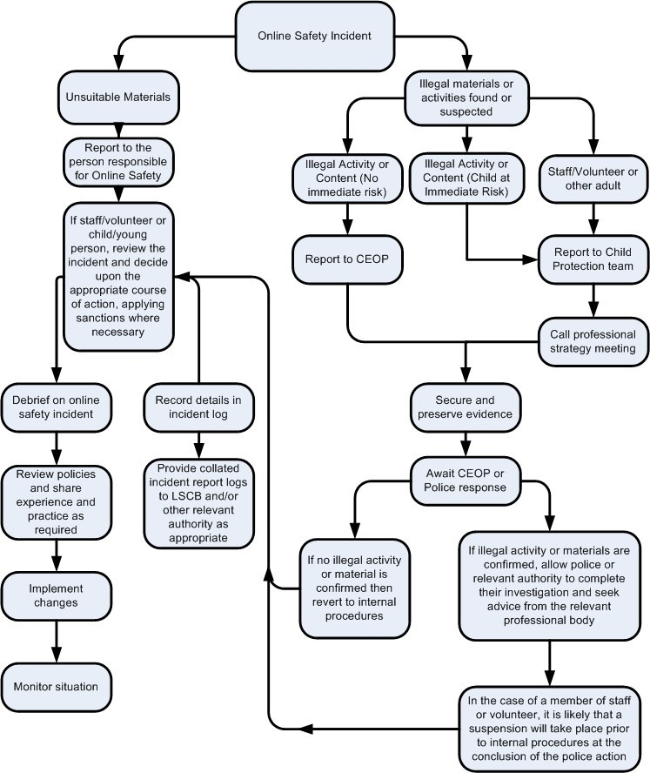

It is hoped that all members of the school community will be responsible users of digital technologies, who understand and follow school policy. However, there may be times when infringements of the policy could take place, through careless or irresponsible or, very rarely, through deliberate misuse.

**In the event of suspicion, all steps in this procedure should be followed:**

* Have more than one senior member of staff/volunteer involved in this process. This is vital to protect individuals if accusations are subsequently reported.
* Conduct the procedure using a designated computer that will not be used by young people and if necessary can be taken off site by the police should the need arise. Use the same computer for the duration of the procedure.
* It is important to ensure that the relevant staff should have appropriate internet access to conduct the procedure, but also that the sites and content visited are closely monitored and recorded (to provide further protection).
* Record the URL of any site containing the alleged misuse and describe the nature of the content causing concern. It may also be necessary to record and store screenshots of the content on the machine being used for investigation. These may be printed, signed and attached to the form (except in the case of images of child sexual abuse – see below)
* Once this has been completed and fully investigated the group will need to judge whether this concern has substance or not. If it does then appropriate action will be required and could include the following:
  + - * Internal response or discipline procedures.
      * Involvement by Local Authority or national/local organisation (as relevant).
      * Police involvement and/or action.

* **If content being reviewed includes images of Child abuse then the monitoring should be halted and referred to the Police immediately. Other instances to report to the police would include:**

|  |  |
| --- | --- |
|  | * incidents of ‘grooming’ behaviour. |
|  | * the sending of obscene materials to a child. |
|  | * adult material which potentially breaches the Obscene Publications Act. |
|  | * criminally racist material. |
|  | * other criminal conduct, activity or materials. |

* **Isolate the computer in question as best you can. Any change to its state may hinder a later police investigation.**

It is important that all of the above steps are taken as they will provide an evidence trail for the *school/academy* and possibly the police and demonstrate that visits to these sites were carried out for child protection purposes. The completed form should be retained by the group for evidence and reference purposes.

### School Actions & Sanctions

It is more likely that the school will need to deal with incidents that involve inappropriate rather than illegal misuse. It is important that any incidents are dealt with as soon as possible in a proportionate manner, and that members of the school community are aware that incidents have been dealt with. It is intended that incidents of misuse will be dealt with through normal behaviour/disciplinary procedures.

|  |  |
| --- | --- |
| **Date this policy was formally reviewed and agreed by the Governing Body of Ravensworth Terrace Primary School:** | |
| Approved by the Governing Body on: |  |
| Reviewed by Head Teacher |  |
| Date: |  |
| Date of next review: |  |