**Ravensworth Terrace Primary School**

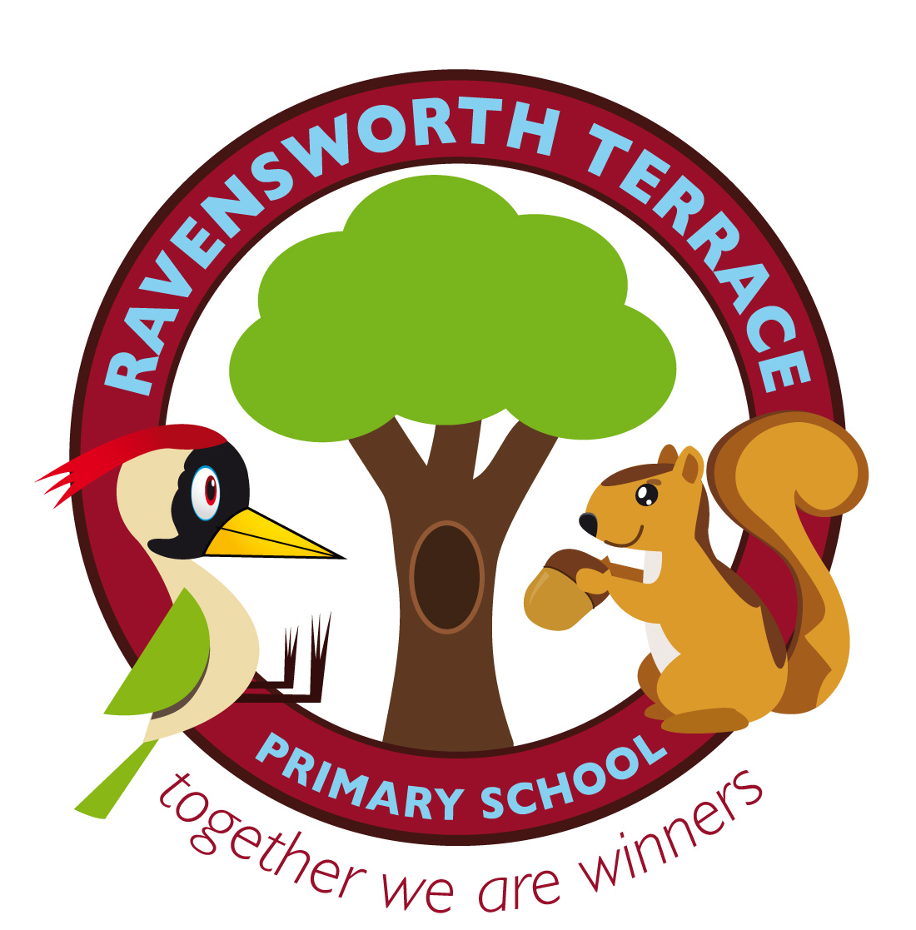

Spiritual, Moral, Social and Cultural (SMSC) Policy

February 2019

At Ravensworth Terrace Primary School we recognise that the personal development of students, spiritually, morally, socially and culturally, plays a significant part in their ability to learn and achieve. We therefore aim to provide an education that provides students with opportunities to explore and develop their own values and beliefs, spiritual awareness, high standards of personal behaviour, a positive caring attitude towards people and an understanding of their social and cultural traditions.

**RIGHTS RESPECTING SCHOOL**

We have achieved the Silver RRSA are working towards becoming a Gold Rights Respecting School. This is in relation to the Unicef Rights Respecting Schools initiative which is provided in order to enable children and young people to make informed decisions and to grow into confident, active and responsible citizens. Teachers use class assembly time to discuss children’s rights from the UN Convention on the Rights of the Child, in addition to other lessons across the curriculum.

**We believe that:**

• All curriculum areas have a contribution to make to the child’s spiritual, moral, social and cultural development.

• All adults will model and promote expected behaviour, treating all people as unique and valuable individuals and showing care and respect for students and their families.

• The school community will be a place where students will find acceptance for themselves and the opportunity to start again where forgiveness is fundamental to the ethos of the school.

• Students should learn to differentiate right and wrong in as far as their actions affect others.

• Students should understand the need for rules within our community.

• Students should be prepared to cope with the demands of Modern Day Britain.

**General aims:**

• To ensure that everyone connected with the school is aware of our values.

• To ensure a consistent approach to the delivery of SMSC issues through the general life of the school.

• To ensure that students know what is expected of them and why.

• To give students an opportunity to reflect and discuss feelings and beliefs.

• To enable students to appreciate and understands cultures and traditions.

• To enable students to explore and develop a sense of social and moral responsibility.

• To enable students to take part in a range of activities requiring social skills.

**DEFINITIONS**

**Spiritual Development** is an understanding and acceptance of self and others faiths and beliefs and is not linked solely to a particular doctrine or faith. Spiritual development, is, therefore, accessible to everyone and should support a continuing quest for a secure individual identity. All areas of the curriculum should contribute to pupils’ spiritual development.

**Moral Development** is acquiring a knowledge and understanding of what is right and wrong is central to moral development. It is the basis upon which the pupils may develop the ability to make judgements about how to behave and it is the standpoint from which to consider the behaviour of others in school and society in general.

**Social Development** refers to the development of abilities and qualities that students need to acquire if they are to play a full and active part in society. It also relates to the growth of knowledge and understanding of society in all its aspects. In the classroom Pupils learn to lead, to use their initiative and to use individual skills and strengths when working together towards a common goal.

**Cultural Development** refers to the development of knowledge and understanding of differing cultural beliefs, customs and traditions. It is an increasing appreciation of the systems of values and attitudes which form the basis of identity and cohesion within societies and groups. In school we aim to celebrate our diversity through embracing opportunities to celebrate and talk about known and unknown experiences.

**Teaching and organisation:**

Development in SMSC will take place across all curriculum areas, within activities that encourage students to recognise the spiritual dimension of their learning and the challenges and implications on their own attitude and lifestyle. All curriculum areas should seek illustrations and examples drawn from as wide a range of cultural contexts as possible. This can be done by class discussions, in small groups, performances and visits / talks from outside visitors.

**RRSA Articles**

**Article 2:** The Convention applies to every child without discrimination, whatever their ethnicity, gender, religion, language, abilities or any other status, whatever they think or say, whatever their family background.

**Article 5:** Respect the rights and responsibilities of parents and careers to provide guidance and direction to their child as they grow up, so that they fully enjoy their rights. This must be done in a way that recognises the child’s increasing capacity to make their own choices.

**Article 13:** Every child must be free to express their thoughts and opinions and to access all kinds of information, as long as it is within the law.

**Article 14:** Every child has the right to think and believe what they choose and also to practise their religion, as long as they are not stopping other people from enjoying their rights. Governments must respect the rights and responsibilities of parents to guide their child as they grow up.

**Article 28:** Every child has the right to an education.

**Article 29**: Education must develop every child’s personality, talents and abilities to the full. It must encourage the child’s respect for human rights, as well as respect for their parents, their own and other cultures, and the environment.

**Article 30:** Every child has the right to learn and use the language, customs and religion of their family, whether or not these are shared by the majority of the people in the country where they live.

**Article 31:** Every child has the right to relax, play and take part in a wide range of cultural and artistic activities.

**Spiritual Development**

Planned opportunities for spiritual development in all subjects can be seen across the school. Children are given opportunities to reflect upon the meaning of spiritual experiences.

Examples of experiences commonly regarded as spiritual include:

• Curiosity and mystery

• Awe and wonder

• Connection and belonging

• Heightened self-awareness

• Prayer and worship

• Deep feelings of what is felt to be ultimately important

• A sense of security, well-being, worth and purposefulness

The school will develop a climate or ethos within which all pupils can grow and flourish, respect others and be respected; accommodating difference and respecting the integrity if individuals. These can occur during any part of the school day, eg. when listening to music, discussing the care needed for animals, exercising empathy or creativity, how we live, contemplating the future, etc.

**Moral Development**

At Ravensworth Terrace Primary School we believe that a morally aware pupil will develop a wide range of skills. These can include the following:

• Distinguish right from wrong, based on knowledge of the moral codes of their own and other cultures

• Develop an ability to think through the consequences of their own and others’ actions

• Have an ability to make responsible and reasoned judgements

• Ensure a commitment to personal values

• Respect others’ needs, interests and feelings, as well as their own

• Develop a desire to explore their own and others’ views, and an understanding of the need to review and re-assess their values, codes and principles in the light of experience

**Our school develops pupil moral development by:**

• Providing a clear moral code as a basis for behaviour which is promoted consistently through all aspects of the school

• Promoting racial, religious and other forms of equality

• Giving pupils opportunities across the curriculum to explore and develop moral concepts and values – for example, personal rights and responsibilities, truth, justice, equality of opportunity, right and wrong

• Developing an open and safe learning environment in which pupils can express their views and practice moral decision making

• Rewarding expressions of moral insights and good behaviour

• Recognising and respecting the codes and morals of the different cultures represented in the school and wider community

• Encouraging pupils to take responsibility for their actions, for example, respect for property, care of the environment, and developing codes of behaviour, providing models of moral virtue through literature, humanities, sciences, arts and assemblies; reinforcing the school’s values through images, posters, classroom displays, etc. and monitoring in simple ways, the success of what is provided.

Teachers always discuss with their classes a code of conduct for the classroom based on the values held by the school. We teach the children to be aware of their own actions, take responsibility for their own bodies and encourage independence. We will help the children to identify their feelings and think these through so that they are expressed in behaviour that is socially acceptable.

This is done through collective worship and SEAL/PSHE/Circle Time sessions. We are interested in the development of the whole child and will endeavour to raise their self-esteem through praise, stickers, Star of the Week, Head Teacher Awards, Achievers Certificates and other means that highlight both academic and social achievements (please refer to our Behaviour Policy).

**Social Development**

At Ravensworth Terrace Primary School we recognise that pupils who are becoming socially aware are likely to be developing the ability to:

• Adjust to a range of social contexts by appropriate and sensitive behaviour

• Relate well to other people’s social skills and personal qualities Work successfully, as a member of a group or team

• Share views and opinions with others

• Resolve conflicts maturely and appropriately

• Reflect on their own contribution to society

• Show respect for people, living things, property and the environment

• Exercise responsibility

• Understand how societies function and are organised in structures such as the family, the school

• Understand the notion of interdependence in an increasingly complex society

**Our school develops pupil social development by**:

• Identifying key values and principles on which school and community life is based

• Fostering a sense of community, with common, inclusive values

• Promoting racial, religious and other forms of equality

• Encouraging pupils to work co-operatively

• Encouraging pupils to recognise and respect social differences and similarities

• Providing positive experiences to reinforce our values as a school community – for example, through assemblies, team building activities, residential experiences, school productions

• Helping pupils develop personal qualities which are valued in a civilised society, for example, thoughtfulness, honesty, respect for difference, moral principles, independence, interdependence, self-respect and an awareness of others’ needs

• Providing opportunities for engaging in the democratic process and participating in community life

• Providing opportunities for pupils to exercise leadership and responsibility

• Providing positive and effective links with the world of work and the wider community

• Monitoring in simple, pragmatic ways, the success of what is provided

**Cultural Development**

Children should be made aware of the diversity of other cultures both within modern Britain and throughout the world. This can be done through music, PE, art and many other curriculum areas.

Pupils who are becoming culturally aware are likely to be developing some or all of the following characteristics:

• An ability to reflect on important questions of meaning and identity

• An interest in exploring the relationship between human beings and the environment

**Our school develops pupils’ cultural development by**:

• Extending pupils’ knowledge and use of cultural imagery and language

• Encouraging them to think about special events in life and how they are celebrated

• Recognising and nurturing particular gifts and talents; providing opportunities for pupils to participate in literature, drama, music, art, crafts and other cultural events and encouraging pupils to reflect on their significance

• Reinforcing the school’s cultural links through displays, posters, exhibitions, etc. As well as developing partnerships with outside agencies and individuals to extend pupils’ cultural awareness, for example, theatre, museum and gallery visits

• Auditing the quality and nature of opportunities for pupils to extend their cultural development across the curriculum in collaboration with the subject leaders of PSHE, RE, MFL & School Council

**Links with the wider community:**

Visitors are welcome into our school. We regard home-school links as crucial enabling parents and teachers to work in an effective partnership to support the students. Finally, students will be taught to appreciate their local environment and to develop a sense of responsibility to it.

**Monitoring and evaluation:**

Provision for SMSC is monitored and reviewed by:

• Monitoring of T&L by co-ordinator.

• Regular discussion with staff.

• Audit of policy and schemes of work.

• Sharing good practise.

• Collation of evidence on school website.

• Learning walk evidence.

• Lesson observation process.

• School Improvement Plan.

**Provision for SMSC is monitored and reviewed by:**

• Monitoring of T&L by co-ordinator.

• Regular discussion with staff.

• Audit of policy and schemes of work.

• Sharing good practise.

• Collation of evidence in school portfolio.

• Learning walk evidence.

• Lesson observation process.

• School Improvement Plan.

Reviewed by D Thompson

October 2019