Relationships and sex education policy
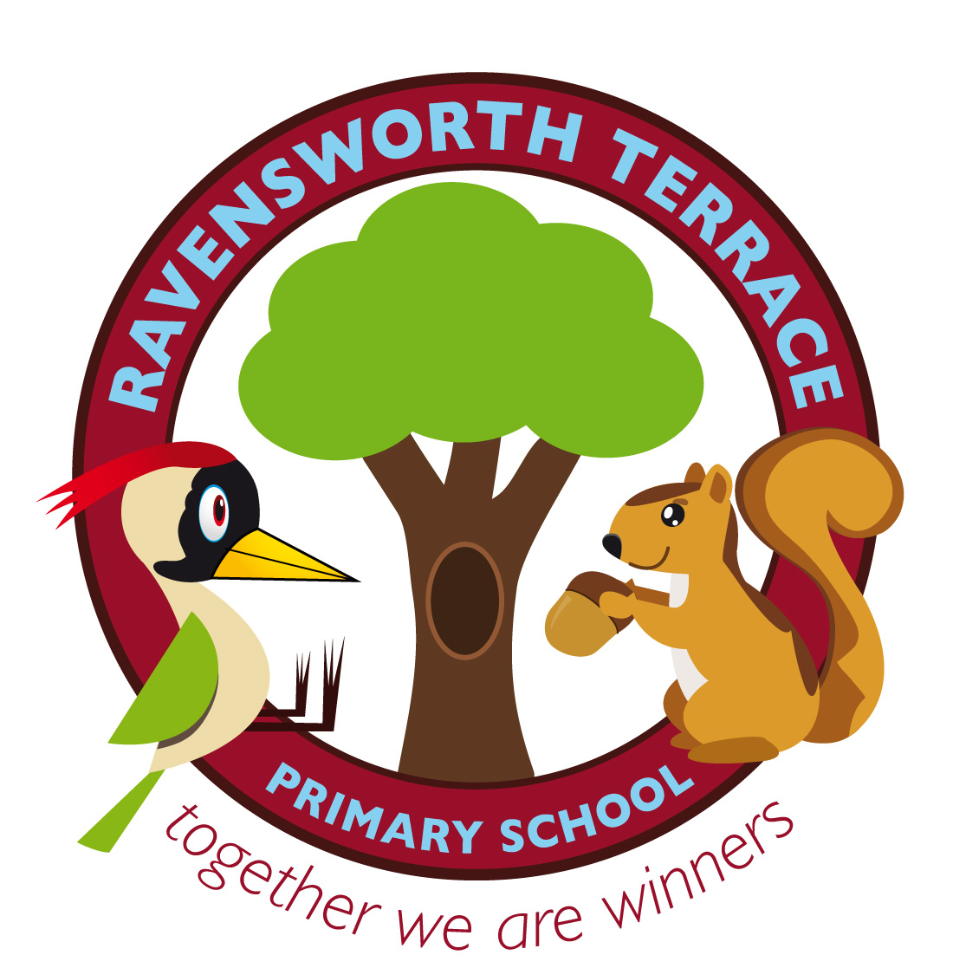

Approved by: Governors |  | Date:
Last reviewed on: July 2021
Next review due by: | July 2022

Contents
1. Aims 2
2. Statutory requirements 2
3. Definition 2
5. Delivery of RSE 2/3
6. Roles and responsibilities 3
7. Parents’ right to withdraw 4
8. Training 4
9. Monitoring arrangements 4
10. Equalities and Diversity……………………………………………………………………………………………………………………………………………..6

1. Aims
The aims of relationships and sex education (RSE) at our school are to:
- Provide a framework in which sensitive discussions can take place
- Prepare pupils for puberty, and give them an understanding of the importance of health and hygiene
- Help pupils develop feelings of self-respect, confidence and empathy
- Create a positive culture around issues of sexuality and relationships
- Teach pupils the correct vocabulary to describe themselves and their bodies
- To empower pupils to be safe and safe guarded

RSE at Ravensworth Terrace Primary School includes all our core values that sustain the positive ethos of our school. Our five Core Values are: Independence, Respect, Perseverance, Team Work and Kindness. The impact of our values is evident in the daily life of the school as well as in our PSHE/RSE curriculum.
We aim to provide children with the knowledge, skills and understanding they need to lead confident, healthy, independent lives and to become informed, active and responsible citizens. In providing children with an understanding of healthy and respectful relationships and appropriate boundaries, we consider effective RSE to be a fundamental part of our approach to supporting pupils to grow into confident, caring, responsible and respectful young citizens.

2. Statutory requirements

At Ravensworth Terrace Primary School we must provide relationships education to all pupils as per section 34 of the Children and Social work act 2017.
However, we are not required to provide sex education, but we do need to teach the elements of sex education contained in the science curriculum which we do in Y5.
In teaching RSE, we must have regard to guidance issued by the secretary of state as outlined in section 403 of the Education Act 1996.
At Ravensworth Terrace Primary School we teach RSE as set out in this policy.

3. Definition
RSE is about the emotional, social and cultural development of pupils, and involves learning about relationships, sexuality, healthy lifestyles, diversity and personal identity.
RSE involves a combination of sharing information and exploring issues and values.
RSE is not about the promotion of sexual activity.
As a school, we have opted out of sex education as defined below:
- what sexual intercourse is, and how it can be one part of an intimate relationship between consenting adults
- how pregnancy occurs i.e. when a sperm meets an egg and the fertilised egg settles
into the lining of the womb
- that pregnancy can be prevented with contraception
- about the responsibilities of being a parent or carer and how having a baby changes someone’s life

Taking into account parental and pupil views, as well as the maturity of the children in our school, we have decided that the curriculum without (what we define as) sex education, is more appropriate for, and strong enough to, build the foundations for specific teaching of these areas in secondary school.

4. Curriculum
Our RSE curriculum is embedded within our PSHE curriculum and is set out as per Appendix 1, but we may need to adapt it as and when necessary taking into account the needs of the pupils.
We have developed the curriculum in consultation with pupils and staff considering the age, needs and feelings of pupils. If pupils ask questions outside the scope of this policy, teachers will respond in an appropriate manner, so they are fully informed and don’t seek answers online. The teacher will then make the parent aware of this discussion if necessary.
Sex education at the primary level is not compulsory (see our definition above) so we are choosing not to cover this. At Ravensworth Terrace Primary School, we believe that it is up to the parents to decide on how much information is given to their children depending on their level of maturity.
From Yr2, the children begin to use the correct terminology to identify and name the main parts of the body including external genitalia (e.g. vulva, vagina, penis, testicles) which will then be developed further in the Summer term of Yr4. This is to ensure that children know how to keep themselves safe and is therefore identified as the safeguarding element in this policy. In the Autumn term of Yr5, with the support of our school nurse, children will learn key facts about puberty and the changing adolescent body, including physical and emotional changes. They will also learn about menstrual wellbeing including the key facts about the menstrual cycle.
The national curriculum for science also includes subject content in related areas, such as the main external body parts, the human body as it grows from birth to old age (including puberty) and reproduction in some plants and animals.

FGM (Female Genital Mutilation)
Although not statutory to teach in primary school, it is recommended that schools start the conversation and lay the foundations of introducing FGM as statistics show that girls are at most risk between the ages of 5-12 years old and therefore, primary schools play an important part in safeguarding girls from FGM. This will be taught in the summer term of Yr5. Please see section 7 about the parental right to withdraw their child from this should they wish to.

For more information about our curriculum, see our Whole School Curriculum Overview in Appendix 1.

British Values
These are embedded throughout the curriculum (please see British Values policy).

5. Delivery of RSE
RSE is taught within the personal, social, health and economic (PSHE) education curriculum. Biological aspects of RSE are taught within the science curriculum, and other aspects are included in religious education (RE). Pupils in Y5 also receive a stand-alone puberty education session delivered by a trained health professional.
Relationships education focuses on teaching the fundamental building blocks and characteristics of positive relationships including:
- Families and people who care for me
- Caring friendships
- Respectful relationships
- Online relationships
- Being safe
These areas of learning are taught within the context of family life taking care to ensure that there is no stigmatisation of children based on their home circumstances (families can include single parent families, LGBTQ parents, families headed by grandparents, adoptive parents, foster parents/carers amongst other structures) along with reflecting sensitively that some children may have a different structure of support around them (for example: looked after children or young carers).
Children will also be taught Physical Health and Mental Wellbeing which will include:
- Mental Wellbeing
- Internet Safety and Harm
- Physical health & Fitness
- Healthy Eating
- Drugs, alcohol and tobacco
- Health and Prevention
- Basic first aid
- Changing adolescent body
Our PSHE scheme has been updated to include the new aspects of RSE. Relationships education, Physical Health and Wellbeing topics are all included under our umbrella core themes of Relationships in the Autumn Term, Living in the Wider World in the Spring Term and Health and Wellbeing in the Summer Term.
For more information about our RSE curriculum, see Appendices 1 and 2.

6. Roles and responsibilities
6.1 The governing board
The governors will approve the RSE policy and hold the headteacher to account for its implementation.
6.2 The headteacher
The headteacher is responsible for ensuring that RSE is taught consistently across the school.
6.3 Coordinators
Anna Roe (AHT), Sophie Dorner and Joanna Kane are responsible for leading and coordinating PSHE and RSE.
6.4 Staff
Staff are responsible for:
- Delivering RSE in a sensitive way
- Modelling positive attitudes to RSE
- Monitoring progress
- Responding to the needs of individual pupils
Staff do not have the right to opt out of teaching RSE. Staff who have concerns about teaching RSE are encouraged to discuss this with the headteacher.
6.5 Pupils
Pupils are expected to engage fully in RSE and, when discussing issues related to RSE, treat others with respect and sensitivity.

7. Parents’ right to withdraw

Parents do not have the right to withdraw their children from relationships and health education.
Sex education at the primary level is not compulsory so at Ravensworth Terrace Primary School we are choosing not to cover this.
In Y5 with the support of our school nurse, children will learn about their changing adolescent bodies and will learn key facts about puberty and the changing adolescent body, including physical and emotional changes. They will also learn about menstrual wellbeing including the key facts about the menstrual cycle.
Content of lessons that teach more explicit terminology, will be shared with parents prior to the delivery. This will ensure that parents are prepared and conversations at home can be continued.

Withdrawal from FGM
The parents of Yr5 pupils, have the right to withdraw from the teaching of FGM as it is not compulsory in primary school.
Parents wanting to withdraw their children are invited to speak to the class teacher. The class teacher will explore the concern of the parents and the possibility of adjusting the programme or approach and will discuss any impact that withdrawal may have on the child. He/she will talk with the parents about the possible negative experiences or feelings that may result from withdrawal of the child and the ways in which these may be minimised. If the parent still wishes to withdraw the child, requests for withdrawal should be put in writing and addressed to the Headteacher.

8. Training
Staff are trained on the delivery of RSE as part of their induction and it is included in our continuing professional development calendar.
The headteacher and senior leaders will also invite visitors from outside the school, such as school nurses or other outside agencies/charities to provide support and training to staff teaching RSE.

9. Monitoring arrangements
The delivery of RSE is monitored by our DHT and AHT alongside with our PSHE Co-ordinators, through:
- Planning, work scrutiny and learning walks.
- Pupils’ development in RSE which is monitored by class teachers as part of our internal assessment systems.
- Parent, staff and pupil questionnaires/surveys.
This policy will be reviewed every two years. At every review, the policy will be approved by the Headteacher, Denise Thompson.

10. Equalities and Diversity
Pupils with special educational needs will be given the opportunity to fully participate in RSE lessons, and a differentiated program will be provided where necessary, to ensure that all pupils gain a full understanding.
Schools, like all public institutions, have specific responsibilities in relation to equality and protected characteristics. Planning and resources are reviewed to ensure they comply with equalities legislation and the school’s equal opportunities policy. All RSE is taught without bias and in line with legal responsibilities such as those contained within the Equality Act (2010). Topics are presented using a variety of views and beliefs so that pupils are able to form their own, informed opinions but also respect others that may have different opinions.
The personal beliefs and attitudes of staff delivering RSE will not influence the teaching of the subject in school. In our school we seek to recognise and embrace the diverse nature of our community. We aim to value and celebrate religious, ethnic and cultural diversity as part of modern Britain. We will explore different cultural beliefs and values and encourage activities that challenge stereotypes and discrimination and present children with accurate information based on the law. We will use a range of teaching materials and resources that reflect the diversity of our community and encourage a sense of inclusiveness. We do not use RSE as a means of promoting any form of sexual orientation.

Protected Characteristics
(Specific aspects of a person’s identify defined by the equality act 2010 and relate to protection from discrimination)

‘…it is important that all children gain an understanding of the world they are growing up in, and learn how to live alongside, and show respect for, a diverse range of people.’
(DFE, Guidance: Inspecting teaching of the protected characteristics in schools, Updated 19th April 2021)

At Ravensworth Terrace, we promote equality and will not tolerate any form of discrimination for those who share the protected characteristics. Our carefully planned curriculum, addresses at least some of the protected characteristics in every year group and is delivered so that our children develop age-appropriate knowledge and understanding of these.

The following characteristics are protected characteristics—
- Age
Through the ‘Growing and Changing’ unit, each year group learns about age appropriate changes that they themselves and others will go through in their lifetime. This continuous and progressive provision, educates our children about age differences, allowing them to understand and respect people of different ages and the things they will experience as they get older. The science curriculum also addresses these changes, particularly in year 5 when they learn about the changes through to old age during the ‘Animals including Humans’ topic.

In year 1, during the ‘Keeping Safe’ unit, children also learn about age restrictions on things such as TV programmes and games, allowing them to understand that these age restrictions are for their own safety.

In previous years (and hopefully this will be able to happen once again), the school choir has visited care homes for the elderly, to sing Christmas songs but more importantly, build mutually respected relationships between the young and old.

- Disability
Many of the units of work in the PSHE scheme, allow for the opportunity to discuss disability- both mentally and physically. Promoting and educating about mental and physical well-being is a unit of work which each year group teaches in the summer term at an age appropriate level. This, as well as ‘Growing and Changing’ and ‘Belonging to a Community’ (particularly in year 5 and 6) allow for discussions regarding individuality, being unique and challenging discrimination.

Charity and awareness events which promote equality, understanding and tolerance of both physical and mental disabilities are viewed as vital importance at Ravensworth Terrace. The staff mental well-being walk and one of our pupil’s ‘Treadmill Challenge’ (for The Danny Green Fund which supports children who require long term physiotherapy following a brain tumour diagnosis and subsequent posterior fossa syndrome (loss of previously mastered abilities) are just two examples of how the school comes together to recognise and raise awareness of physical and mental disability ensuring that our pupils have an understanding and respect for everyone.

Please also refer to our mental health and SEN policies.

- Gender Reassignment;
Although this is not specifically taught at Ravensworth Terrace, as it is encouraged at secondary school, the foundations about ‘gender identify’ and everyone’s right to be loved regardless of their gender are introduced in the autumn term of year 6 in the ‘Families and Friendships’ unit.

- Marriage and Civil Partnership;
In our curriculum, children begin to learn about different kinds of relationships from year 1, in the ‘Families and Friendships’ unit of work. They are taught about different types of families, which includes same-sex, as well as married and unmarried couples. This is then further developed in year 3. In year 6, children learn about what marriage and civil partnership are and their rights to choose who, if and when they marry.

- Pregnancy and Maternity;
As we have opted out of sex education, this protected characteristic is not taught at Ravensworth Terrace.

- Race
The ‘Respecting Ourselves and Others’ and ‘Belonging to a Community’ units, both offer all year groups (particularly from year 2) the opportunity to address race, with the main focus being on respecting the differences between people regardless of race, gender or ethnicity.

As well as our PSHE curriculum, each year group also learns about Black History Month in October.

In year 5 and 6, pupils participate in the ‘Show Racism the Red Card’ workshop which promotes equality and respect and educates pupils on what racism is and what can be done to stop it.

- Religion or Belief
The ‘Respecting Ourselves and Others’ and ‘Belonging to a Community’ units, both offer all year groups (particularly from year 2) the opportunity to address race, with the main focus being on respecting the differences between people regardless of race, gender or ethnicity.

Please also refer to our RE curriculum/policy.

- Sex
Although not explicitly taught until year 3, as a school, we ensure that there is no male/female stereotyping beginning in EYFS by choosing the correct words to use with the pupils as well as challenging and discussing any stereotyping views.

In year 3, during the ‘Money and Work’ unit, children are taught about common myths and gender stereotypes in the workplace. This is then built on in year 5, where the children learn about the impact that stereotyping can have and how to challenge it. Year 6 pupils then progress further with this, in their ‘Belonging to a Community’ unit. Here they do a range of work on discrimination in general but also more on recognizing and challenging stereotypes and the impact and influence stereotypes have on attitudes and understanding.

Using Primary Futures resources, we hold an annual ‘Aspirations Week’ for the whole school. This involves looking at different career paths, challenging work-place stereotypes, informing children of what qualification certain jobs require and looking at the route they could take to achieve these goals. The week ends with children dressing up as ‘what they want to be when they grow up’. It is inspirational to see pupils challenging those stereotypes and choosing jobs that society can sometimes perceive as gender specific.

- Sexual Orientation.
In year 6, pupils are taught about the difference between sexual orientation and gender identify and everyone’s right to be loved. Our school’s continuous provision, ensures that throughout the school, regardless of one’s sexual orientation, that everyone is treated with respect. Each year, to further promote this, Pride Month is celebrated in all classes.

Homophobic language, such as using the word ‘gay’ as an insult, is not tolerated at Ravensworth Terrace.

11. Links with other policies

British Values
- Mental Health and well-being
- SMSC
- Anti-bullying
- Behaviour and Discipline
- Staff well-being
- Equality and Diversity

Appendix 1: By the end of primary school pupils should know
Topic | Pupils should know
Families and people who care about me | - That families are important for children growing up because they can give love, security and stability  - The characteristics of healthy family life, commitment to each other, including in times of difficulty, protection and care for children and other family members, the importance of spending time together and sharing each other’s lives  - That others’ families, either in school or in the wider world, sometimes look different from their family, but that they should respect those differences and know that other children’s families are also characterised by love and care  - That stable, caring relationships, which may be of different types, are at the heart of happy families, and are important for children’s security as they grow up  - That marriage represents a formal and legally recognised commitment of two people to each other which is intended to be lifelong  - How to recognise if family relationships are making them feel unhappy or unsafe, and how to seek help or advice from others if needed
Caring friendships | - How important friendships are in making us feel happy and secure, and how people choose and make friends  - The characteristics of friendships, including mutual respect, truthfulness, trustworthiness, loyalty, kindness, generosity, trust, sharing interests and experiences and support with problems and difficulties  - That healthy friendships are positive and welcoming towards others, and do not make others feel lonely or excluded  - That most friendships have ups and downs, and that these can often be worked through so that the friendship is repaired or even strengthened, and that resorting to violence is never right  - How to recognise who to trust and who not to trust, how to judge when a friendship is making them feel unhappy or uncomfortable, managing conflict, how to manage these situations and how to seek help or advice from others, if needed
Respectful relationships | - The importance of respecting others, even when they are very different from them (for example, physically, in character, personality or backgrounds), or make different choices or have different preferences or beliefs  - Practical steps they can take in a range of different contexts to improve or support respectful relationships  - The conventions of courtesy and manners  - The importance of self-respect and how this links to their own happiness  - That in school and in wider society they can expect to be treated with respect by others, and that in turn they should show due respect to others, including those in positions of authority  - About different types of bullying (including cyberbullying), the impact of bullying, responsibilities of bystanders (primarily reporting bullying to an adult) and how to get help  - What a stereotype is, and how stereotypes can be unfair, negative or destructive  - The importance of permission-seeking and giving in relationships with friends, peers and adults
Online relationships | - That people sometimes behave differently online, including by pretending to be someone they are not  - That the same principles apply to online relationships as to face-to face relationships, including the importance of respect for others online including when we are anonymous  - The rules and principles for keeping safe online, how to recognise risks, harmful content and contact, and how to report them  - How to critically consider their online friendships and sources of information including awareness of the risks associated with people they have never met  - How information and data is shared and used online
Being safe | - What sorts of boundaries are appropriate in friendships with peers and others (including in a digital context)?  - About the concept of privacy and the implications of it for both children and adults; including that it is not always right to keep secrets if they relate to being safe  - That each person’s body belongs to them, and the differences between appropriate and inappropriate or unsafe physical, and other, contact  - How to respond safely and appropriately to adults they may encounter (in all contexts, including online) whom they do not know  - How to recognise and report feelings of being unsafe or feeling bad about any adult  - How to ask for advice or help for themselves or others, and to keep trying until they are heard  - How to report concerns or abuse, and the vocabulary and confidence needed to do so  - Where to get advice e.g. family, school and/or other sources

