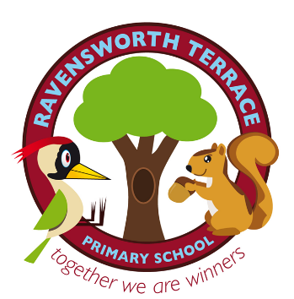**Ravensworth**

Terrace Primary School

Mount Pleasant Road, Birtley DH3 1AY Telephone (0191) 4334200

Email:ravensworthterraceprimaryschool@gateshead.gov.uk

**Head Teacher: Mr A Ramanandi**

Dear Families

We believe that uniform is an important part of our school’s identity. It reinforces who we are as a community and helps encourage children to feel pride in our school. It also ensures children are not put under any pressure because of the type of clothes they wear and all are treated equally. Unfortunately, over the last few months we have noticed that our uniform has become less ‘uniform’ and there are a number of interpretations of what is and is not acceptable. This letter will therefore clarify our expectations, for you and your child.

**School Uniform**

We expect children to wear a maroon jumper/cardigan and white shirt with grey skirt/pinafore dress or trousers. Children should wear their tie every day. We also expect children to wear plain black shoes. Plain black trainer style shoes are acceptable as long as they do not have brightly coloured or white labels, logos, soles or markings.

White polo shirts, grey shorts and blue checked dresses can be worn in the summer term.

A variety of uniform items are available to order and these proudly display our school logo. Uniform can be ordered online by visiting the school website. Cardigans and ties are available from the school office. School coloured clothing is also available from local shops and supermarkets as well as online. We also have a stock of good condition second hand uniform donated by parents and carers. Ask at the school office if you are interested.

You can order school uniform by logging on to the school website which is [www.ravensworthterrace.com](http://www.ravensworthterrace.com) .

**P.E. Clothing**

Children need a change of clothing and footwear to enable them to take part in PE lessons. Indoor lessons can sometimes be in bare feet, however appropriate footwear for outdoor lessons is needed. PE kit should be brought to school on a Monday and taken home for washing each Friday. Our school PE kit consists of white plain t-shirt and black shorts and a gym bag.

**Outdoor Clothing**

Please send your child to school with a suitable coat for the outdoors which is clearly labelled with their name inside. Please send wellies for the outdoors which can be kept in school. Wellies need to be labelled with your child’s name clearly marked inside. We encourage children to make the most of all the outdoor opportunities available and at times this may mean that they come home muddy!

**\*Please ensure ALL clothing brought to school, including outdoor coats etc are clearly labelled with your child’s name. This means that any lost property can be quickly returned to the owner.**

**Jewellery**

We discourage the wearing of jewellery in school for the health and safety of the children, however a wrist watch may be worn. If absolutely necessary, studs may be worn in pierced ears but children must be able to remove them independently for a PE lesson and these are brought into school entirely at the children’s own risk. Children will be required to remove any items of jewellery which contravenes this code; items will be confiscated until parents collect them from school.

**Make Up/Hair/Nails**

Make up of any description is not allowed. Nail varnish is not allowed. False nails are not allowed. Please do not allow children to come to school with for example brightly coloured hair or extreme haircuts.

Staff will be vigilant in ensuring children are dressed smartly in their school uniform. We really appreciate your support in helping us maintain high standards of appearance here at school.

Yours faithfully



Mr A Ramanandi

**Head Teacher**